1.開啟痰液收集瓶的瓶蓋。注意：請勿觸碰收集罐及瓶蓋的內側。Unscrew the lid of sterile sputum cup. Be aware of not touching inner cup and lid

2. 將痰液直接咳入收集瓶內，請深咳喉嚨深部的痰液(不是咳出口水)。Cough deeply to expectorate sputum directly into the container. Do NOT expectorate any saliva.

3. 痰液咳入收集瓶後，請將瓶蓋鎖緊，避免痰液流出。Screw on the lid. Do not contaminate the rim of the container with sputum.

4. 將痰液檢體放入夾鏈袋中，交給檢驗人員。Put container in the safety bag provided, return to the laboratory.

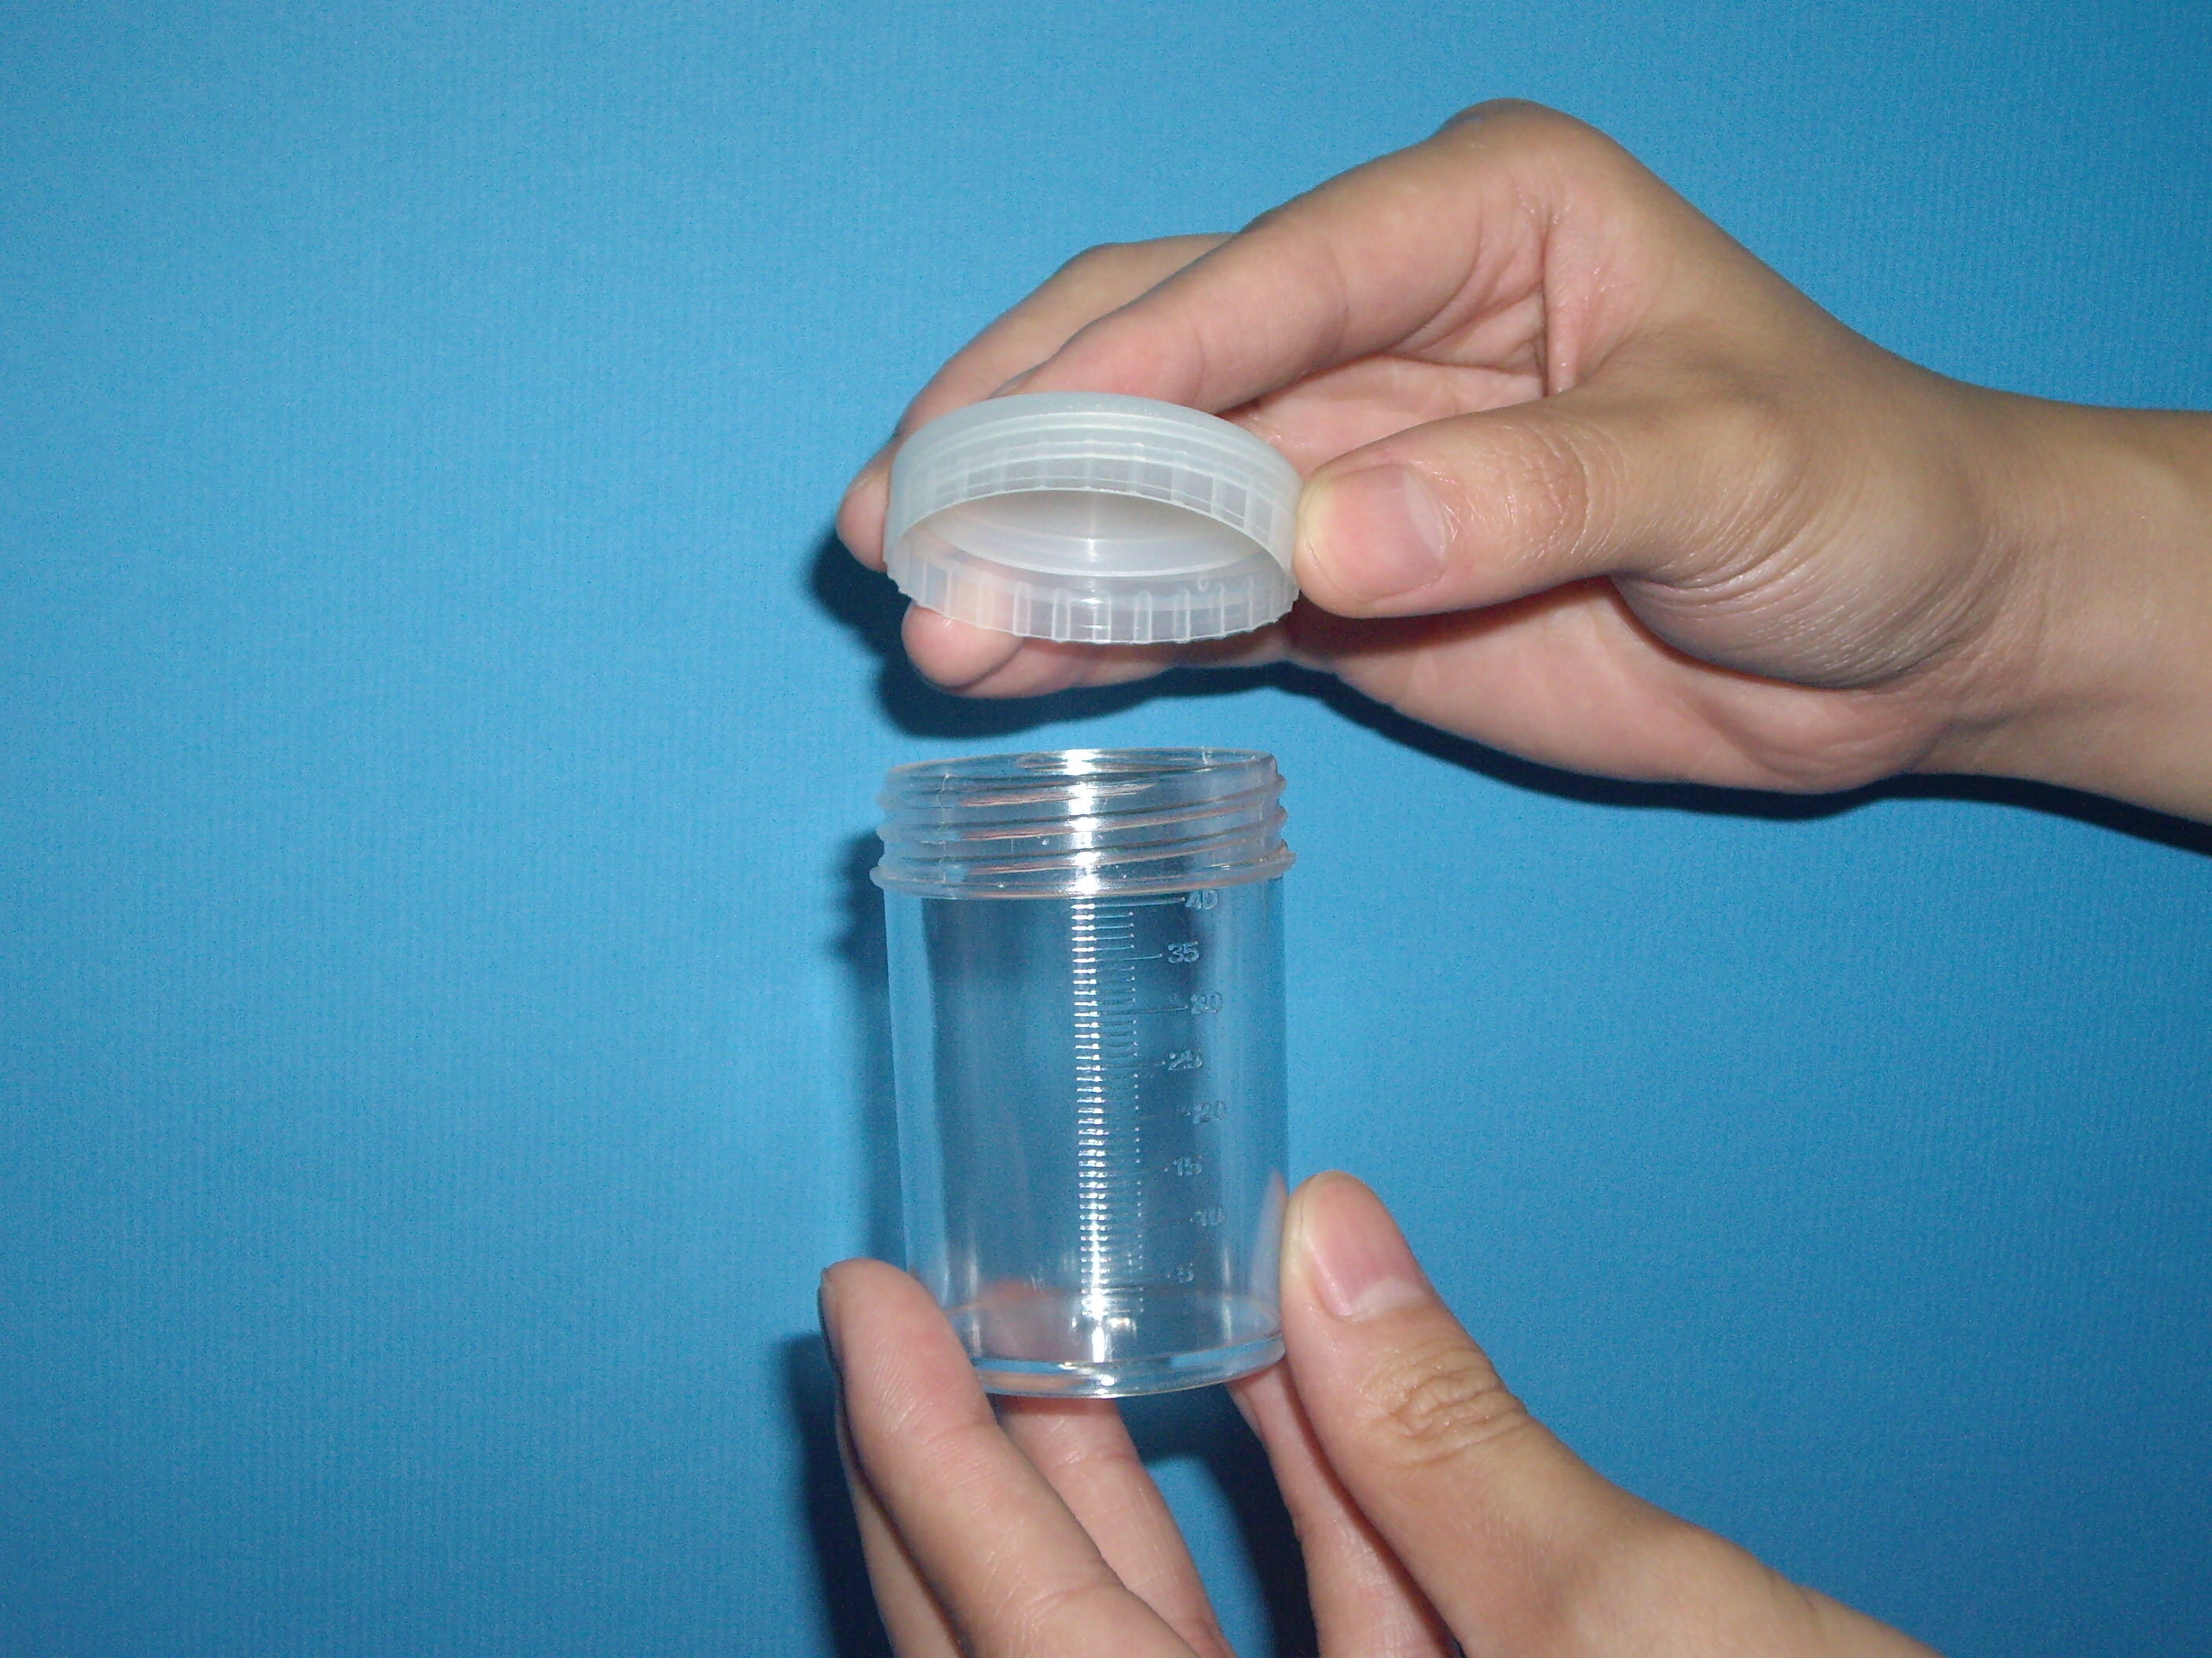

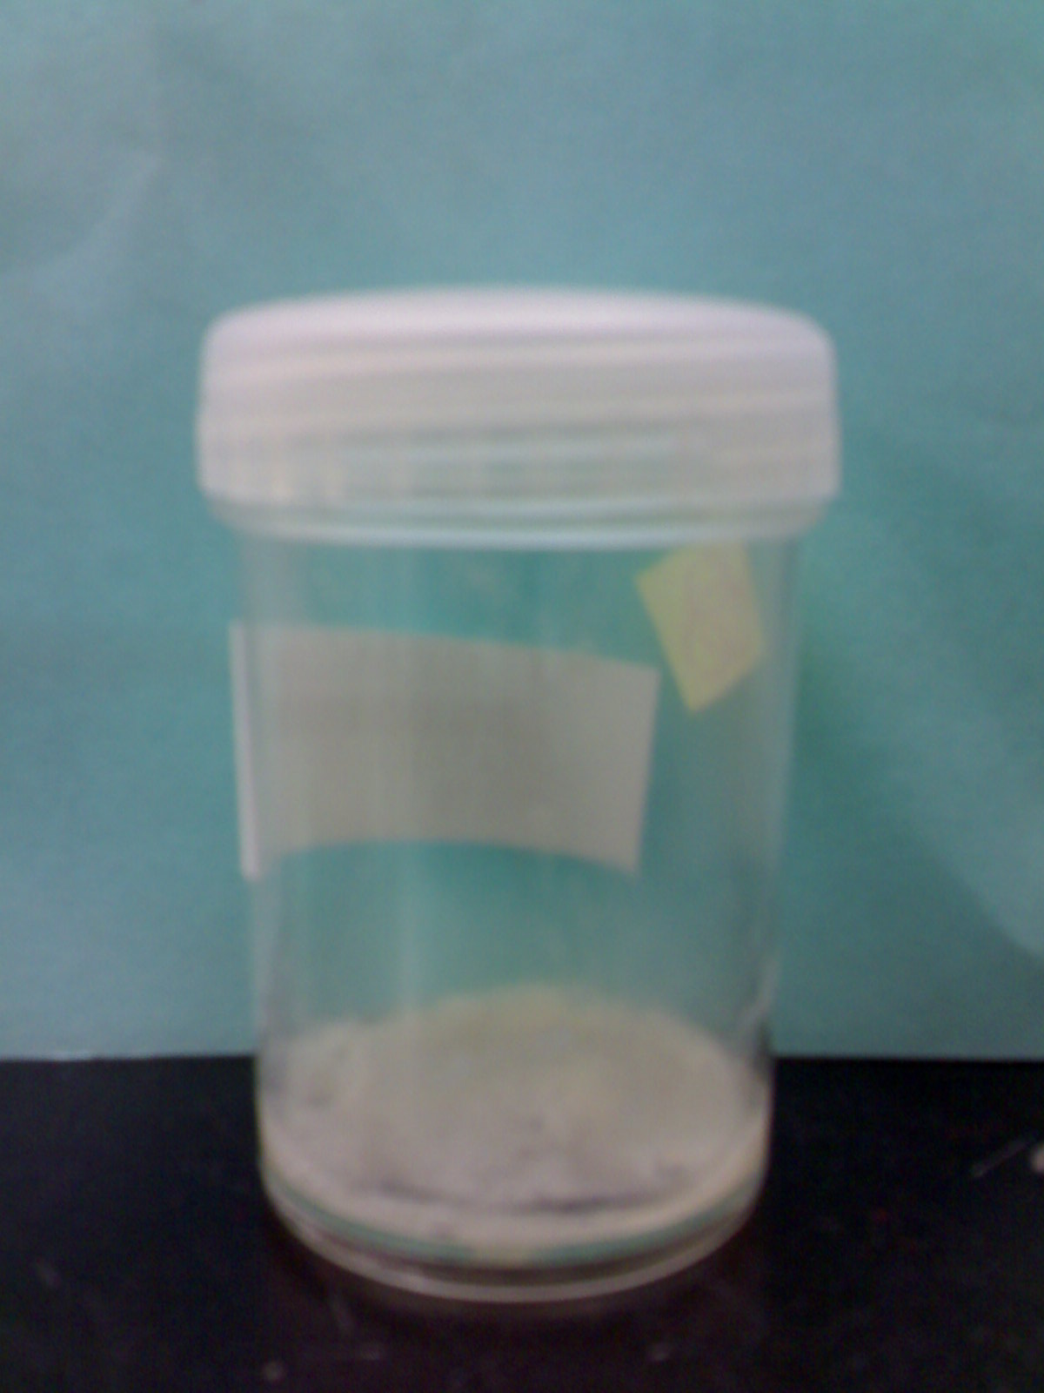

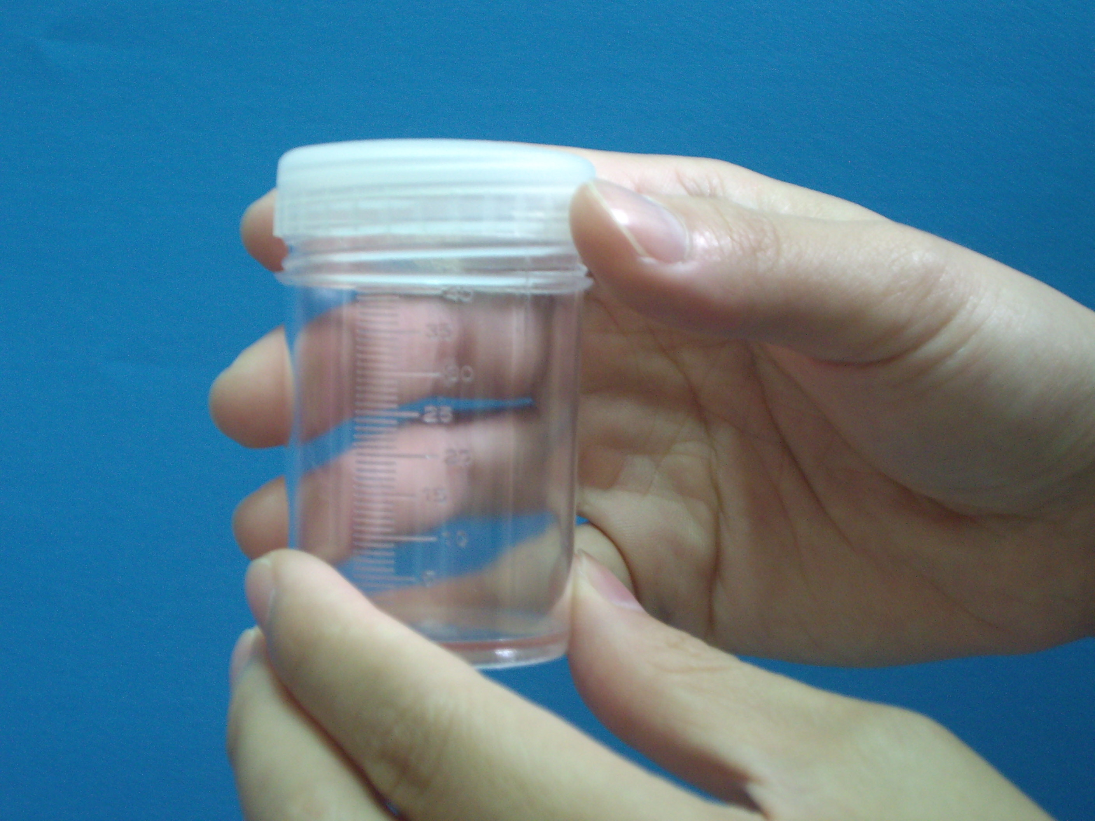

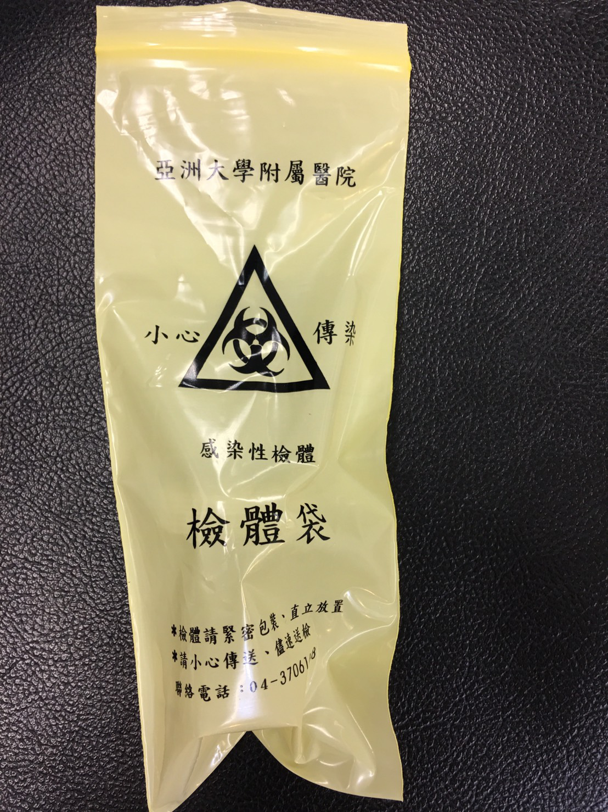

注意事項：

1. 請收集早晨第一口痰。First sputum in the morning is preferred.

2. 咳痰前請以「清水」漱口（勿用市售漱口水），避免漱口水殘留在口腔內影響檢驗結果。Rinse your mouth with water. Do not use antiseptic mouthwash, which may interfere in result.

3.咳出的痰液量應儘量不少於5c.c.。Spit secretions into container should not less than 5 ml

4.應於1小時內迅速送達檢驗科，若無法立即送達請暫存於冰箱冷藏室（約4~8℃）。Return specimen collected to the laboratory within 1 hour. Cold storage (4~8℃) is acceptable when specimen is unable to return to the laboratory shortly

5.收檢地點：亞洲大學附屬醫院2F檢驗科。

亞洲亞洲大學附屬醫院檢驗科 2020.10 AUH-YT20-QP035D

**收集痰液培養檢體步驟**

**Sputum specimen collection procedure**